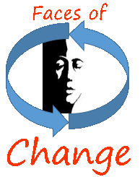
INSPIRE!
What’s your leadership style?
EXPLORE!
Use your unique abilities to
IMPACT
YOUR
COMMUNITY!

BE THE CHANGE YOU WISH TO SEE IN THE WORLD!
--Ghandi

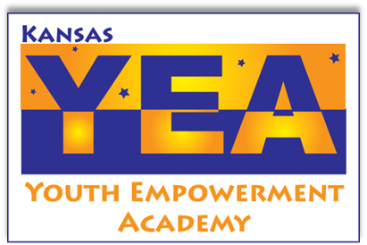

Faces of Change is an advanced leadership program offered by the Kansas Youth Empowerment Academy, for youth ages 16 through 25 years old.
Do you have leadership skills that you are ready to develop? Are you ready to create change in your community?
Join us for one fantastic weekend a month, from March 2019 through October 2019. Meet other youth with all types of disabilities who are motivated to take their skills to the next level: to learn effective leadership approaches through teamwork, motivation, mentors, leadership challenges, and a whole lot of fun.
Are you ready to be inspired? Are you ready to create change? Let’s do this!
Apply Now!
For more information, contact us by email
faces@kyea.org
Or by phone: 785.215.6655

FACES OF CHANGE FACT SHEET

Who?
- Looking for: young adults who already demonstrate aspects of leadership.
- 12-15 people, ages 16 through 25, who have a disability.
- Facilitated by KYEA staff and people who are leaders in Kansas.
- Guest speakers, group activities, videos, and more interactive aspects included in each session.
What?
- The “next step” in advocacy.
- Focuses on leadership, service, and commitment to others.
Why?
- To learn different leadership styles and what works for you.
- To learn: motivation, communication styles, teamwork, how to utilize mentors, and how to improve community issues.
- To learn to work with others in service to a cause that you believe in.
- To learn the connections between leadership and civic engagement.
- With this knowledge, you’ll prepare to make a change or to complete steps toward that change in your own community.
When/Where?
  - Seven month program (one weekend a month, March through October, excluding July).
  - Each session is about a different aspect of leadership and is held at a conference hotel in Topeka.
  - Arrive Friday evening, check out Sunday afternoon. Food and hotel are free!
  - Attendance at all sessions is expected with very few exceptions granted. (Helpful tip: Communicate!)
How?
- Fill out an application. Make sure you follow the directions exactly!
- Contact 2 people (not in your family) who will write a letter of recommendation for you. There is a Reference Form at the back of your application.
- We can suggest resources and help you problem-solve any barriers you might face in filling out the application or attending the sessions.
- Professional level work is expected, so, like most young people, you may find yourself with questions or needs to properly complete the application. Let us know how you need help.
- You will be contacted for an interview soon after returning all paperwork.
Hurry! You don’t want to miss this opportunity!

